Technical Datasheet for TnH Sensor Prob (Metal)
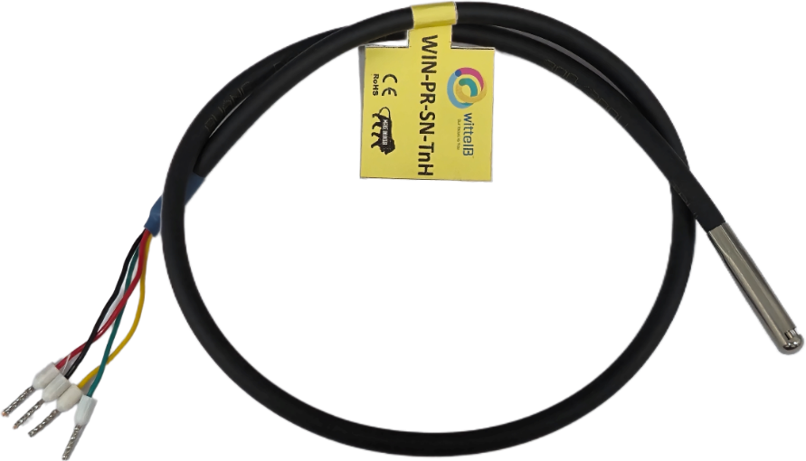
The TnH (Temperature and Humidity) Sensor Module provides highly accurate environmental readings over a standard I2C interface. Designed for straightforward, local integration, this sensor is highly efficient, boasts low power consumption, and is exceptionally easy to deploy in custom hardware builds.

Hardware & Design
- Rugged Metal Probe: The internal temperature and humidity sensing elements are securely housed within a durable, protective metal casing. This robust physical design shields the sensor from physical damage and environmental wear, making it suitable for a wide variety of indoor or enclosed monitoring applications.
- I2C Communication: This module utilizes a simple, two-wire I2C communication protocol (SDA, SCL). This makes it the perfect choice for short-distance, localized data acquisition where direct connection to a master microcontroller (such as a Raspberry Pi, Arduino, or custom DAQ board) is required.
- Wiring Interface: The probe features a flexible, multi-core pigtail cable with exposed wire leads, allowing technicians to quickly terminate and solder the connections directly to their expansion boards or terminal blocks.

Pin | Name | Color | Description
1 | VDD | Red | Power Supply (3.3V/ 5V)
2 | SDA | Yellow | I2C line SDA
3 | SCL | Green | I2C line SCL
4 | GND | Black | Common Ground

Specifications
General –
Power Input Supply – 3.3 & 5V DC
Storage Temperature -20 - 70° C (-4 ~ 158°F)
Storage Humidity 5 ~ 95 % RH, non – Condensing

Certifications

 | Sensor Name | Temperature  Measuring Range | Humidity  Measuring range | AQI/ GAS/ Pressure | Measuring Accuracy | Supply (VDD)
☐ | AHT20 | -20 ~ 85°C | 0~100% RH. | N/A | 0.3°C, 2.0 %RH | 3.3V/ 5V
☐ | AHT21 | -40 ~ 120°C | 0~100% RH. | N/A | 0.3°C, 2.0 %RH | 3.3V/ 5V
☐ | SHT40 | -40 ~ 125°C | 0~100% RH. | N/A | 0.2°C, 1.8 %RH | 3.3V
☐ | SHT45 | -40 ~ 125°C | 0~100% RH. | N/A | 0.1°C, 1.0 %RH | 3.3V
☐ | BME280 | -40 ~ 85°C | 0~100% RH. | 300 - 1100 hPa | 1.0°C, 3.0 %RH,  1.0 %hPa | 3.3V
☐ | BME680 | -40 ~ 85°C | 0~100% RH. | 300 - 1100 hPa  & 0 – 500 IAQ | 1.0°C, 3.0 %RH,  0.6 %hPa, 15 %IAQ | 3.3 V
☐ | BME688 | -40 ~ 85°C | 0~100% RH. | 300 - 1100 hPa  & 0 – 500 IAQ | 0.5°C, 3.0 %RH,  0.6 %hPa, 15 %IAQ | 3.3 V
☐ | BME690 | -40 ~ 85°C | 0~100% RH. | 300 - 1100 hPa  & 0 – 500 IAQ | 0.5°C, 3.0 %RH,  0.5 %hPa., 15 %IAQ | 3.3 V

Contact us: -
Augmatic Technologies Pvt. Ltd.,
Plot no 6, Shah Industrial Estate II,
Kotambi,
Vadodara – 391510.
Email – Sales@wittelb.com
Support: support@wittelb.raiseaticket.com / +91 94038 92805

